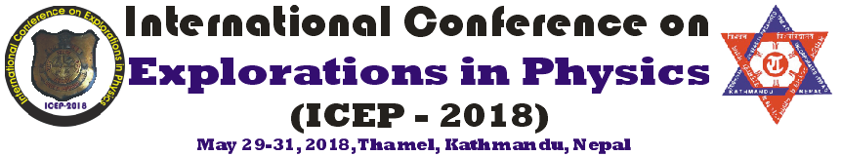

Notice!

It is our pleasure to announce that the Department of Physics, Amrit Campus, is going to organize a 3 day “International Conference on Explorations in Physics, ICEP-2018” from 29 May to 31 May 2018 at the Department of Physics, Amrit Campus, Thamel, Kathmandu, Nepal.

All the Physics faculties and research students are welcome to attend the program.
Please find the conference brochure along with the registration form for your convenience.
Key Dates:
April 30, 2018: Submission portals open
May 15, 2018: Deadline for paper or abstract submission
(Preference for full papers)
May 16, 2018: Notification of acceptance
For online application: http://bit.ly/2w7qdWV
Registration Fee: (i) National Faculty: NRS. 2000/-
(ii) International Participant: USD. 100/-
(iii) National Student: NRS. 1000/-
Early applications are strongly encouraged.

____________________________________
Dr. Leela Pradhan Joshi(SOC, Chair) / Dr. Rajendra Parajuli(LOC, Chair)
Physics Dept., Amrit Campus, Thamel, Kathmandu, Nepal
Email: amrit.icep@gmail.com

